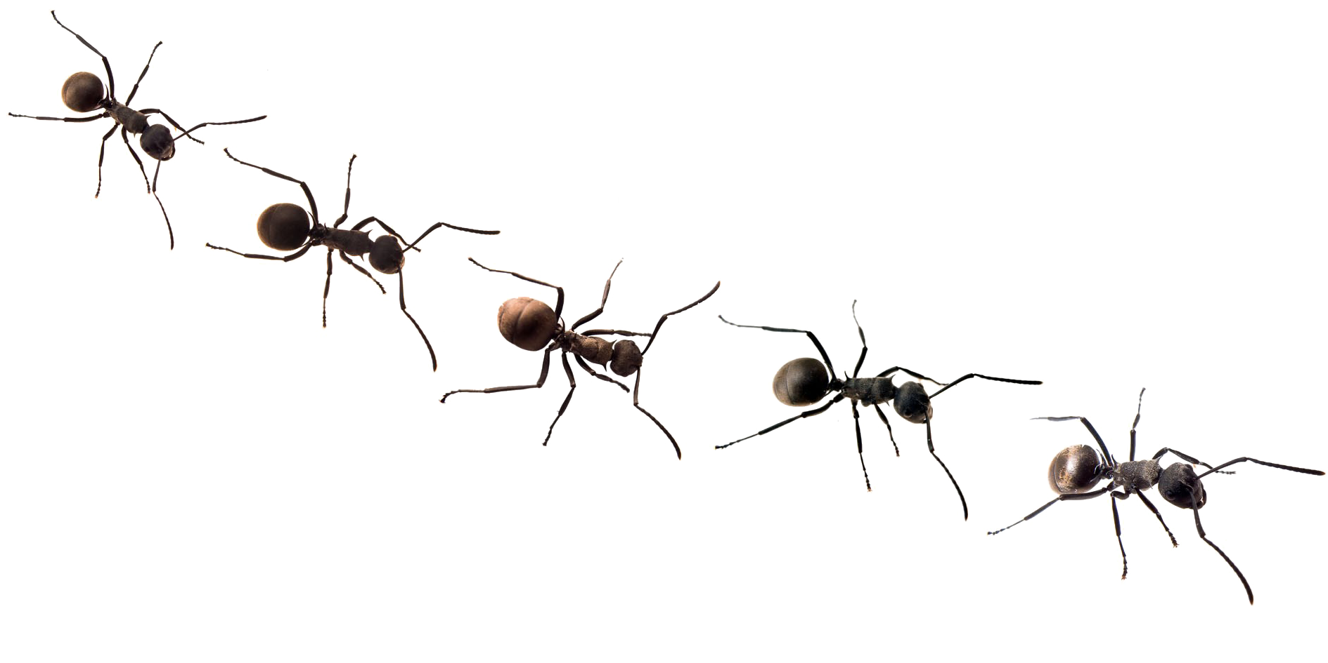
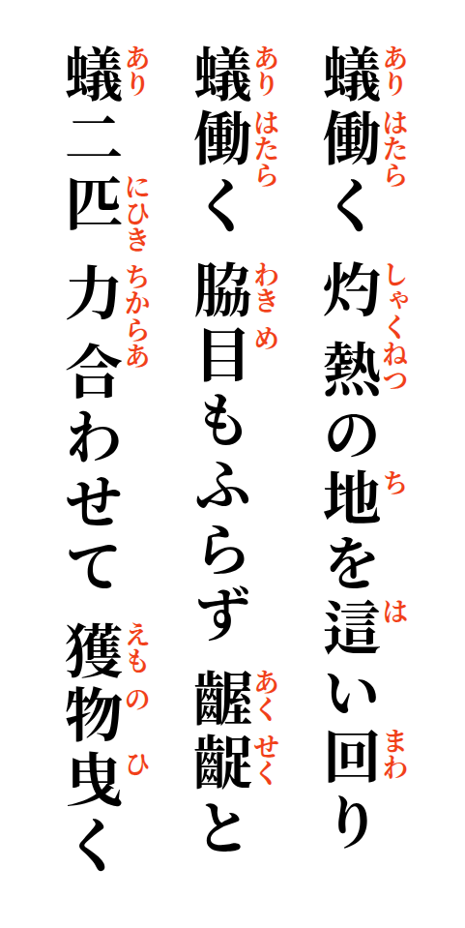

Working ants crawling all over the scorching earth.
Ants working, never looking aside, so restlessly.
Two ants, combining their strength drag their prey.

